Step1. Create IAM role (EC2 role for Aws System manager)

Note: while creating role select use case as **Ec2 Role for AWS system manger**

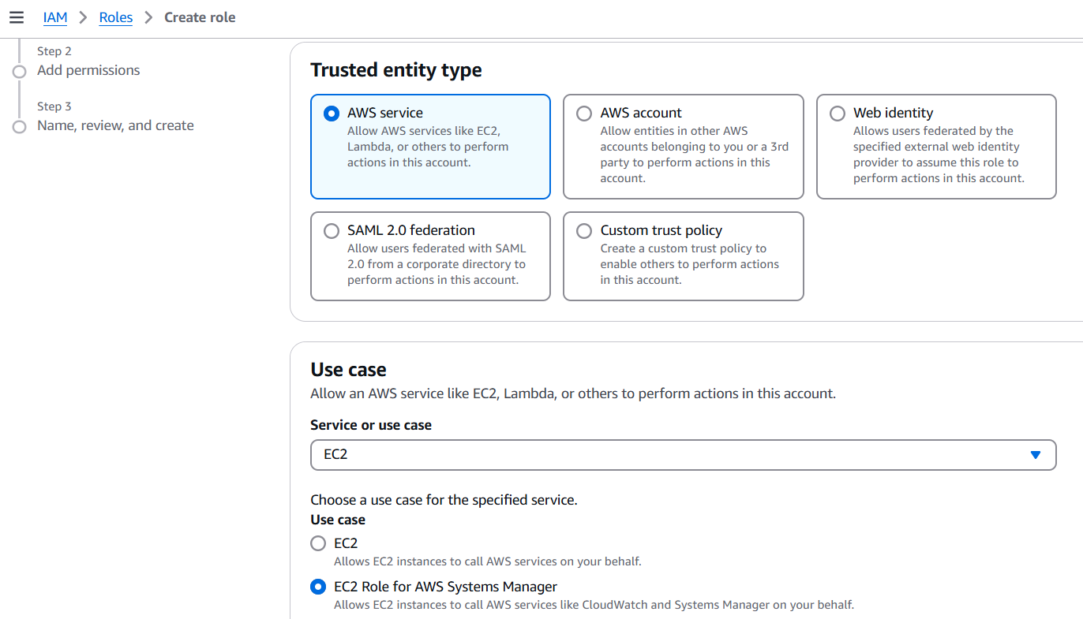

Step2: continue with the specified policy.(click next)

Note:If you select usec case **Ec2 Role for AWS system manger** [AmazonSSMManagedInstanceCore](https://us-east-1.console.aws.amazon.com/iam/home?region=eu-west-1#/policies/details/arn%3Aaws%3Aiam%3A%3Aaws%3Apolicy%2FAmazonSSMManagedInstanceCore) policy will be attached directly.

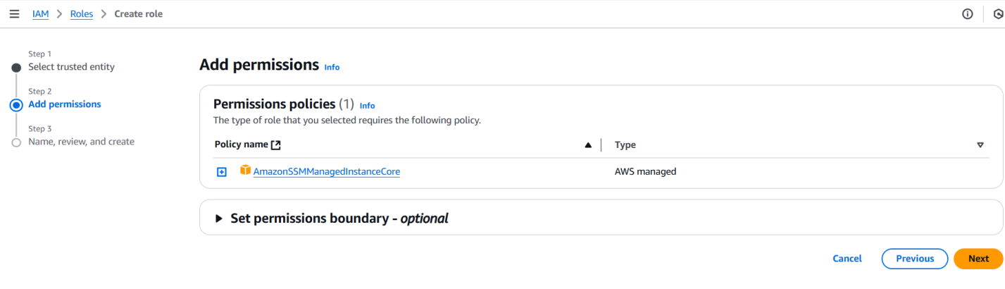

Step3:Give Role name and click create role

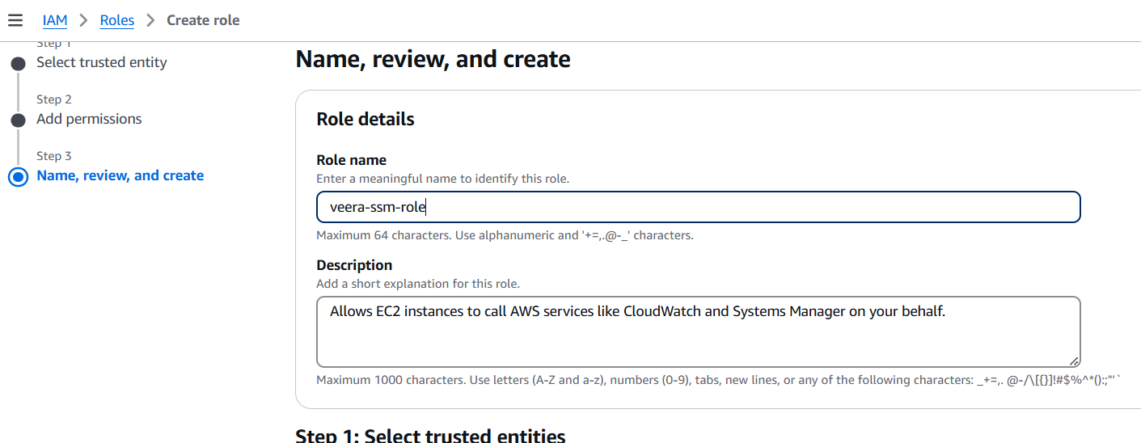

Step:4 Launch Ec2 Instance

Note: While launching the Ec2 instance ,select Advance details and choose IAM instance profile and attaché our role(veera-ssm-role).

If you attach role after creation of ec2 it may take long time to be active.

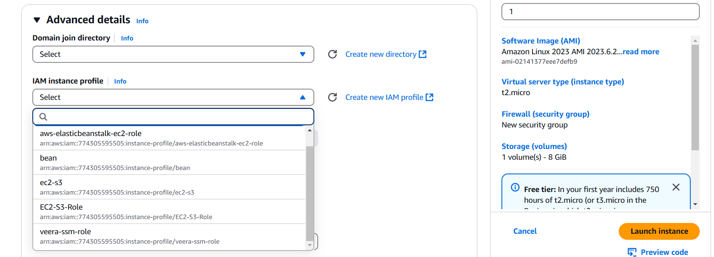

Step:4

The instance is ready and you can connect through session manager.

